# **Assignment 4**

Gavyn Gallagher

MSDS 460

**Question 1. (Review Assignment/Problem Set 2 Question 5)**

Example 5.7 Finding a critical path in a project from Williams (2013, pages 95–96) is an example of a network problem. Following Williams’ lead, in Assignment/Problem Set 2, you set up the problem in your preferred platform for mathematical programming, solved the problem, and checked your solution against the reported solution in the textbook. Describe how you might reconsider the problem if you had uncertainties about the service times for each of the activities. That is, describe the critical path problem as a network of queues. Construct an event graph for the home construction project. (Hint. Think of it as a network of queues.)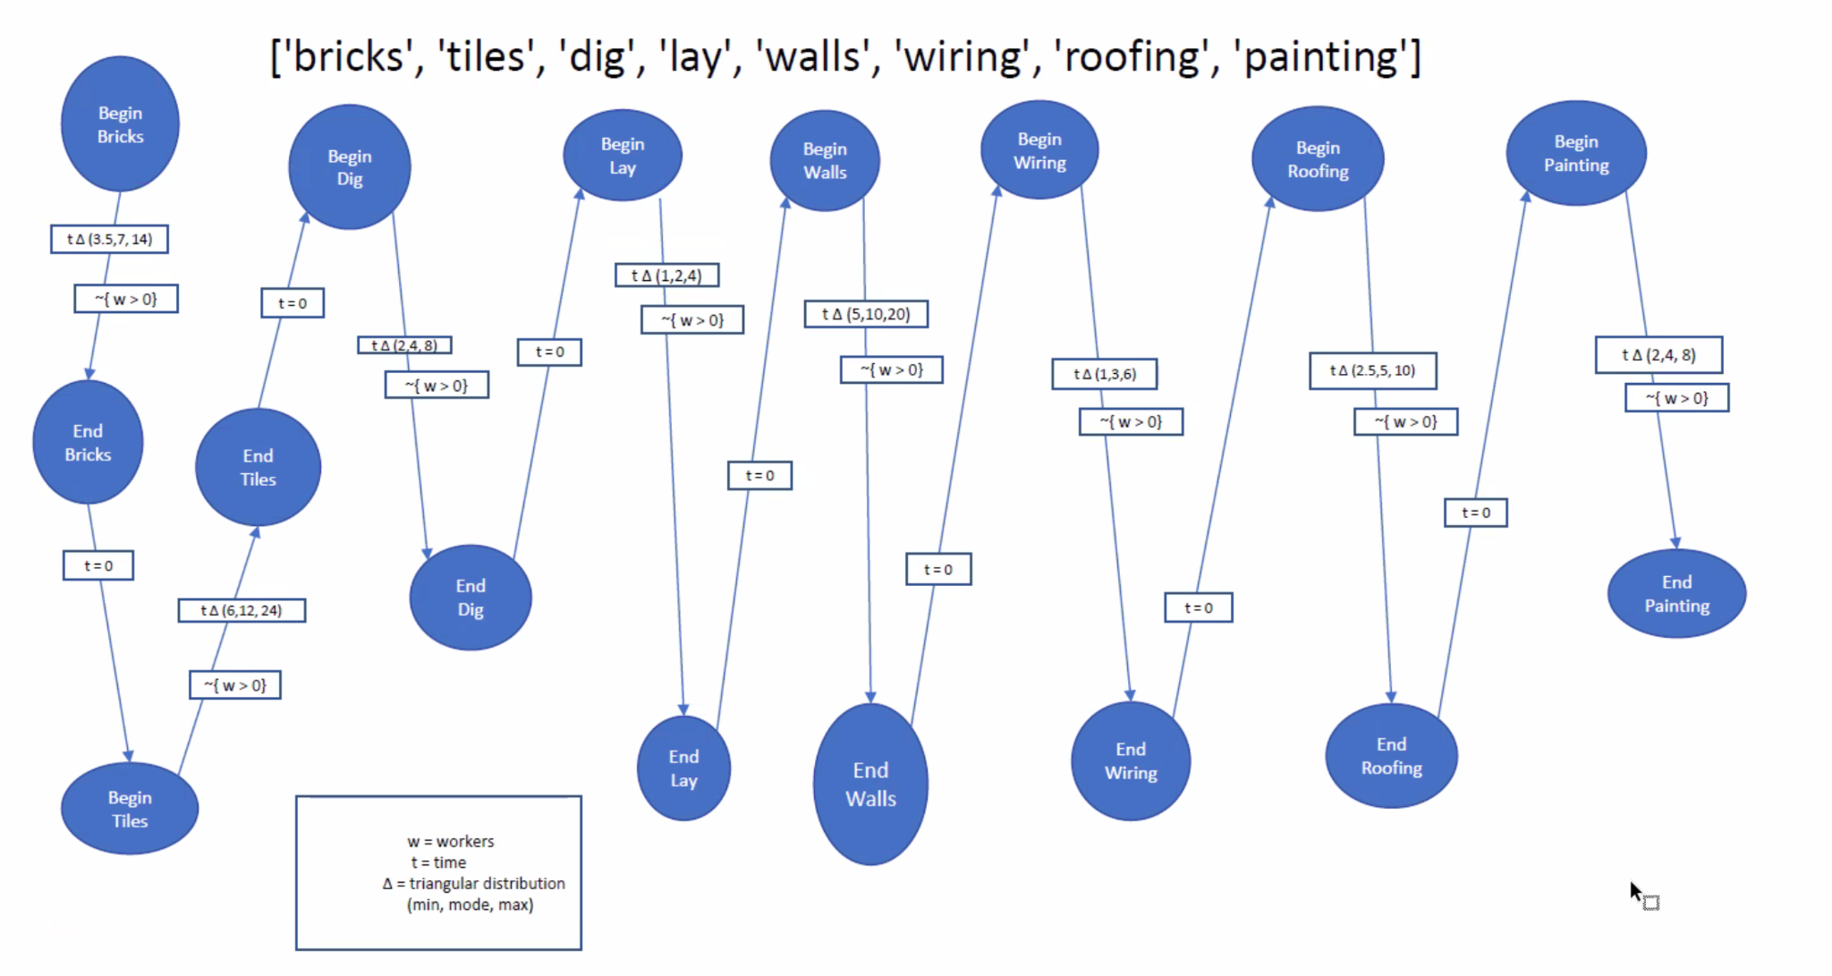

**Question 2.** Williams (2013) provides service times as fixed duration in days. Suppose instead that these times represent mean durations in days for average workers. Consider alternative probability distributions for service times in a house building project. What types of distributions make the most sense? Which distribution would you recommend for a discrete event simulation for home construction? (Note that “obtain bricks” and “obtain tiles” represent a different type of activity from the other activities. These are dependent on a supply chain and maybe best modeled by arrival time distributions.)

There are two types of distributions: continuous and discrete. Both types include various segments:

Continuous Distributions**:**

* **Triangular distribution***:* is useful for approximating a few existing data points and estimating the minimum, mode, and maximum values. It allows modeling an asymmetric probabilistic structure. Should be used when information about the distribution is not known, and a minimum and a maximum is.
* **Uniform distributions***:* If there is limited available information and finite support, you will use this distribution instead of the triangular distribution. This distribution sets all the probabilities equal to each other.
* **Exponential distribution***:* It is often used to model failure/breakdown for a component or a machine.
* **Normal distribution:** Known as the Bell curve. Data points form a symmetrical shape around the mean.

Discrete Distributions:

* **Bernoulli distribution***:*Has two possible outcomes. Could be used for quality material issues
* **Poisson distribution***:* Used to represent the occurrence of a random number of events in a given time period. Usually used on rare events.

First, we must determine if we should use a continuous distribution or a discrete distribution. Continuous distributions are where data can take on any value in a given range. While discrete distributions data can only take on certain values in a given range. The construction problem deals with the average number of days to complete the service. Certain tasks in the problem take a specific amount of time to complete such as obtaining bricks takes 7 days. The amount of time it takes to complete each step is a minimum and could be greater. Obtaining bricks could take 8,9,10 days. Each task could take more leading to the project finishing possibly finishing at many different values. Since the project completion time can be 26 days, 27 days, … 100 days, I would say this is a continuous distribution as the output could take on any value in a given range.

Triangle distribution is a type of continuous distribution. I believe the Triangle Distribution would be best. For there is a minimum amount of time required to complete the project and most likely a maxim amount of time as well. I do not if a majority of the time the project will complete at the minimum nor the maximum. Since I do not know the distribution the triangle would be best to use. The Python chart below shows how a triangle distribution appears.

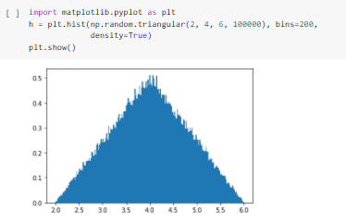

# 

# 

# 

# 

# 

# 

# 

# 

# 

# **Question 3.** Implement the discrete event simulation in software of your choosing (**Python/Simpy**, R/Simmer, Go/Simgo, or Simio). Run the discrete event simulation a few hundred times. Compare the results of the simulation with the optimal solution obtained through mathematical programming.

Mathematical programming way:

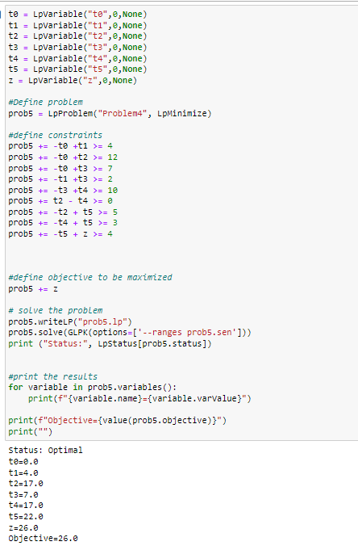

Here the optimal value had a project completion time of 26 days

New code was written using discrete-event simulation software and triangle distribution. This code is much too long to paste here in the problem, it can be found in the appendix and in a separate ipynb file. The code simulates for both problems 3 and 4.

In the simulation, the code was able to run multiple times, 65 runs to be exact. The output of the code can be seen below as well as in an attached csv file. Only one employee was used to simulate the project for this specific problem. The mean of the simulation time, column G, shows the mean is somewhere between 26 and 28.

We know from the mathematical program that the optimal value is 26. The simulation never did have a mean of that optimal value. However, it was very close in its mean. The construction company through the simulation should be confident that they can finish the project somewhere between 26 and 28 days with one employee.

Figure of problem 3 code output:

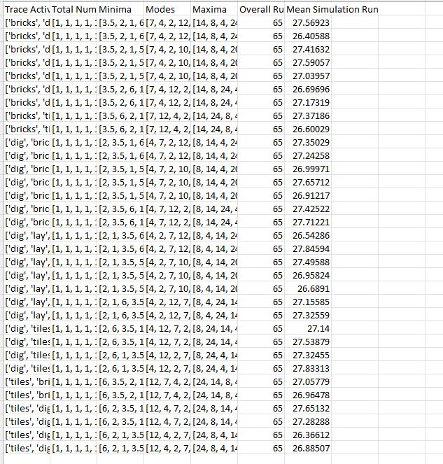

**Question 4.** Williams describes a practical extension to the problem of allocating resources to activities. Activities such as wiring, and roofing may require more than one person (resource). Suppose you add resource constraints to the simulation model you constructed in Question 2 and ran in Question 3. Suppose there are **4 workers only**. Two are required to do wiring and two are required to do roofing. Rerun the simulation a few hundred times with these resource constraints. How do the resource constraints affect the expected time to construct the house?

In this problem, there are two workers to do wiring and two to do roofing. Problem 3, I used one worker to complete the entire construction project. Now there are more workers to help to complete a couple of the tasks. The same code that is used in problem 3 is also used in problem 4. The output generated for each problem are separate. See the output below, to look at problem 4’s output. One of the simulations had an average above 28 which is a new maximum. Overall the mean duration needed to complete the project decreased. The additional workers helped speed up the time slightly. Furthermore, adding more workers to other tasks would also increase the speed. From a business perspective, the more added workers would decrease profit. Being slightly faster on average while paying more employees may not be viewed as worth it.

Figure: Sample of the output for problem 4. To see the entire output, look at the attached csv file.

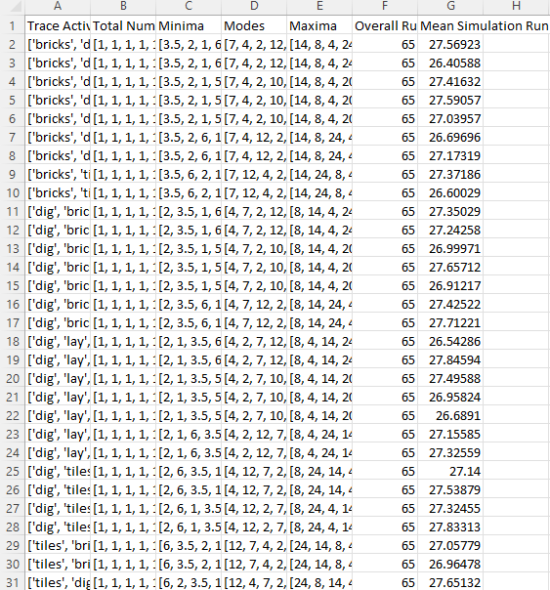

**Question 5.** Compare mathematical programming versus discrete event simulation approaches to the critical path home construction problem, discussing advantages and disadvantages of each approach. If you ran your own construction company, which approach would you use?

**Compare mathematical programming versus discrete event simulation approaches to the critical path home construction problem**

Mathematical Programming focuses on producing an optimal value. whether that is minimizing or maximizing an objective function. Constraints are made, the goal is to reduce all constraints as much as possible while still producing a feasible solution.

Discrete Event Simulation(DES) is a simulation of the behavior of a sequence of defined events over time. The eight tasks (dig, lay, wiring,..) are treated as discrete events to be completed. Then there is a simulation that uses random sampling to see how many days it would take to complete the construction project. The simulations run over and over hundreds of times. If there was an outlier run it would be masked by all the others and the average time of all simulations should give an accurate depiction of how long it would realistically take.

**Advantages and disadvantages of each approach**

Mathematical Model

| Advantages | Disadvantages |
| --- | --- |
| * Easy to construct * Optimizes constraints * Finds an optimal solution | * Does not account for time * Unrealistic assumptions * Could be infeasible or unbounded * No guarantee of integer solutions v |

Discrete Event Simulation

| Advantages | Disadvantages |
| --- | --- |
| * Accounts for time * Handles complexity well * Real-world behaviors can be modeled * Incorporates randomness * flexible | * Difficult to construct * Not all problems have events that can be defined * Is a simulation, is only an estimate * Time consuming |

**If you ran your own construction company, which approach would you use?**

A mathematical model is great for finding the optimal value. For this construction problem, the optimal value would be the minimum amount of time in order to complete the project. Discrete event simulation uses probability to show the amount of time it would take to complete by simulating the project many times over. AN average of the simulation shows it would take ___ days. I view construction as a real-world problem where things go wrong and the optimal value will not always be reached. I would rather see an average of a simulation that ran one thousand times to see an accurate depiction of what to expect. For construction, I would use Discrete event simulation.

# Appendix

Code used for problem 3 & 4

